How to upgrade LP40 software through LP40 LAN port

This is only for the case you cannot upgrade the software for LP40 software by MMC 818.
You need “OfficeServ Manager Launch Pad” program to upgrade x.pgm file via LAN port.
- Configure local network between LP40 and your computer, you can use either cross-over cable or hub.
- Connect SIO cable to LP40 from your computer and follow the instruction below.

Let the LP40 card restart by pressing reset button on LP40

[Boot PGM] <<< Boot Program of LP40 >>> LP40 BOOT & UNIT TEST V1.04: 2005/09/23
[Boot PGM] Read netinfo from eeprom
- IP : 165.213.89.187
- GW : 165.213.89.1
- SM : 255.255.255.0
- MAC: 0000F0E821D5
[ B S P] LTX972 PHY INIT : PASS
[ENTER] ← Press [enter] key at this point.
[Boot PGM] RTCS creation is OK!

[Boot PGM] STOP the load to DRAM by Consol command
[Boot PGM] Enter password !
lp40samsung (or LP40SAMSUNG) ← Input it as password
*******************************************************************************
* LP40 Consol command help ... IAP Development Group *
* [Version: LP40 BOOT & UNIT TEST V1.04: 2005/09/23] *
*-----------------------------------------------------------------------------*
* HELP ... LP40 help command *
* LOAD ... File upload from PCMMC via lan interface *
* READIP ... Network parameter infomation display(IP,MAC ...) *
* WRITEIP ... Network parameter write(IP addr + Auto setting) *
* ex) WRITEIP 160.217.70.9 *
* WRITEIP2 ... Network parameter write(IP addr + Gateway addr + subnet mask) *
* ex) WRITEIP2 160.217.70.9 160.217.70.1 255.255.255.0 *
* MACR ... MAC address read *
* MACW ... MAC address write(Only MAC addr) *
* ex) MACW FF 34 56 *
* TESTON ... DEVICE CHIP Auto Checking Write/Read ON *
* TESTOFF ... DEVICE CHIP Auto Checking Write/Read OFF *
* RESET ... Restart Card *
* FORMAT ... Format NOR Flash Memory *
* VER ... S/W version display *
* LMEM ... Dump memory(list memory) ex) LMEM st_addr (end_addr) (w/l) *
* WMEM ... Modify memory(write memory) ex) WMEM addr val (b/w/l) *
* *
*******************************************************************************

[Boot PGM] System Network Configuration
- IP : 165.213.89.187
- GW : 165.213.89.1
- SM : 255.255.255.0
- MAC: 0000F0E821D5

[Boot PGM] Invalid Command
WRITEIP xxx.xxx.xxx.xxx ← You need to change IP address by this command to match your network
or PC. After running this command, you can see the below messages
but just ignore them.

writeip 165.213.89.156 ← this is example of above
*** spi_write: Time out while writing!
*** spi_write: Time out while writing!
*** spi_write: Time out while writing!
*** spi_write: Time out while writing!
*** spi_write: Time out while writing!
*** spi_write: Time out while writing!
*** spi_write: Time out while writing!
*** spi_write: Time out while writing!
*** spi_write: Time out while writing!
*** spi_write: Time out while writing!
*** spi_write: Time out while writing!
*** spi_write: Time out while writing!

[Boot PGM] System Network changed
- IP : 165.213.89.156
- GW : 165.213.89.1
- SM : 255.255.255.0
- MAC: 0000F0E821D5

[Boot PGM] !!! After card restart, this network information is valid

[Boot PGM] Invalid Command

[Boot PGM] Invalid Command
load ← when you want to upload the LP40 software to LP40.

[Boot PGM] <<< Please download file from PCMMC >>>
[Boot PGM] System Network Configuration
- IP : 165.213.89.156
- GW : 165.213.89.1
- SM : 255.255.255.0
- MAC: 0000F0E821D5

[Boot PGM] System is ready to download ...

- Now open the OfficeServ Launch Pad and execute the “OSM_OS100” or “OSM_100P”
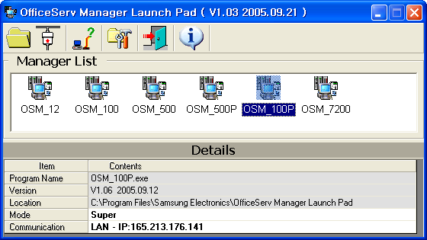

- Configure the “CommSetup”
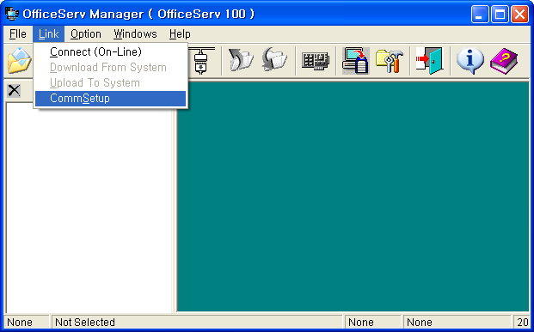
- Setup the IP address below should be that of LP40 which you set through SIO port.
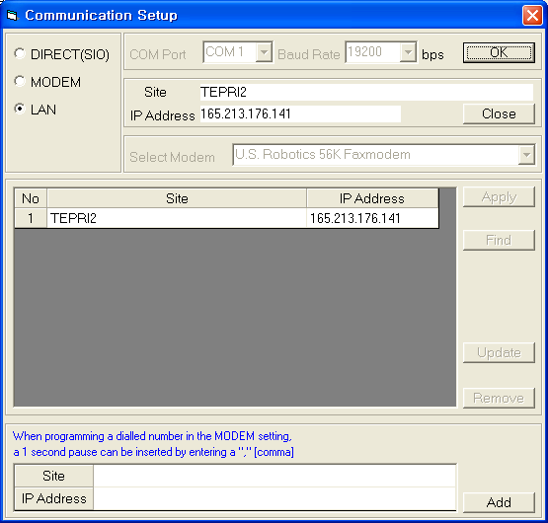

- Choose File upload[Off-line]
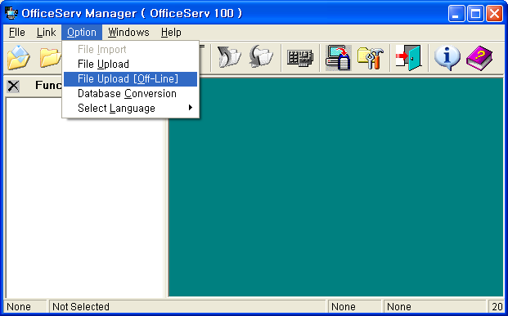
- Select the LP40’s xxx.pgm file by pressing “Open” tab, which you want to upgrade.
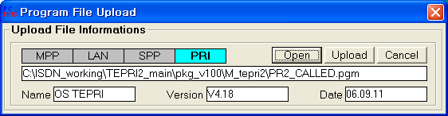

- Press Upload tab
- Now “Input Dealy Time” window shows and put the value as “40” and then press enter key from your PC.
- Now software upgrading process starts.
- Although the below window appears, neither close the window nor press confirmation tab until LP40 software is completely upgraded. You can aware of that through SIO window.
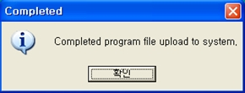

- Wait for finishing the upgrade and close above window.
- LP40 will automatically restart after finishing the upgrade.

